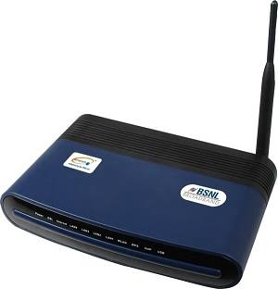

Visitor Mgt

192.168.1.2

**DEPLOYMENT PLAN/ NETWORK DSIGN FOR VIVIAN FOWLER MEMORIAL COLLEGE**

INTERNET MODERM (Behind Haven1)

192.168.1.1

Database Server

(Security Post)

IP: 192.168.1.224

HAVEN 2

192.168.1.214

HAVEN 1

192.168.1.215



Network Switch 1



REG UNIT

192.168.1.2

Regular Switch 2

Bridge

C:\Users\vessiet\Desktop\unnamed.jpgC:\Users\vessiet\Desktop\images.jpgC:\Users\vessiet\Desktop\j1.jpg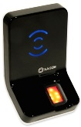

Terminal IN

(Girls Hostel)

192.168.1.212

Terminal OUT

(Girls Hostel)

192.168.1.211

Regular Switch 3

Bridge